**I am going to the**

**Bartlett Public Library District**

# Outside of the library buildingThey are open:

* **Monday to Thursday**: 9:00 a.m. - 9:00 p.m.
* **Friday**: 9:00 a.m. - 6:00 p.m.
* **Saturday**: 9:00 a.m. - 5:00 p.m.
* **Sunday**: 12:00 p.m. - 5:00 p.m.

# If I am...

outside of the library building

* Worried
* Unsure
* Confused

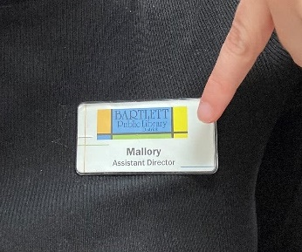I can call them at **630-837-2855** or email them at **askus@bartlettlibrary.org**

# Around the Library

I can ask the staff to show me around the library.

I can talk to any staff member at the library. I can identify them by their name badge.

staff name badge

People usually go to the library to talk, relax, read books, or study. The library is usually quiet, and we use our inside voices so everyone can focus and enjoy their time.

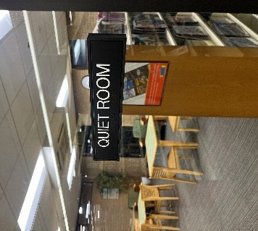Sometimes the library can get noisy. If it is too noisy for me, I can talk to library staff. They can help me find somewhere quiet to go.

There are three main departments in the library:

* Adult – 1st Floor
* Young Adult – 1st Floor
* Youth – 2nd Floor

quiet room at the library

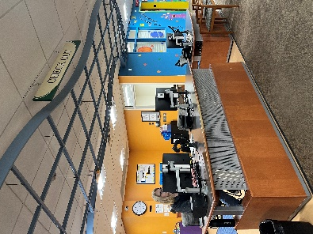Joining the Library  
When I get to the library, I will go to the desk on the left.

circulation desk – this is where i will get a library card or check out an item to bring home with me

I will talk to the friendly library staff about joining.

I will tell them my name and where I live.

I will show them my identification, like a driver's license or a bill. If I don’t have one, I can bring my parents or someone else to help me.

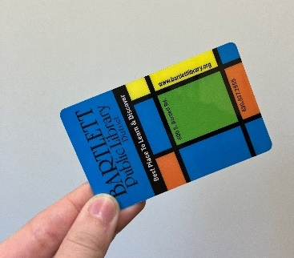I will be given a library card and then I will be a library member.

Bartlett Public Library District library card

# When I Visit the Library

The library has shelves of books, DVDs, CDs, video games, audiobooks, magazines, and more.

If I can’t find something, I can ask a library staff member for help. I will know someone is a staff member because they will be wearing a name badge.

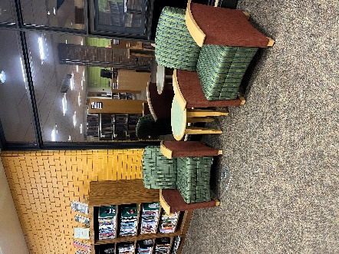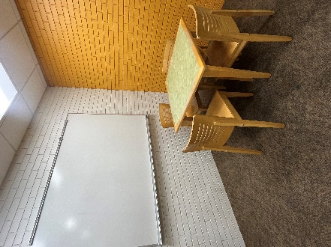I can sit in the library and read or do work.

quiet and private study room at the library

places to sit at the library

Or I can use my library card to borrow a book or other item to take home.

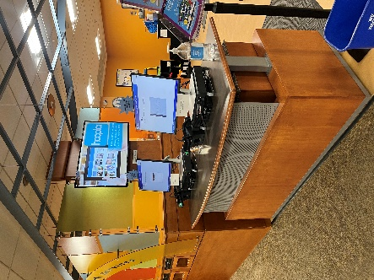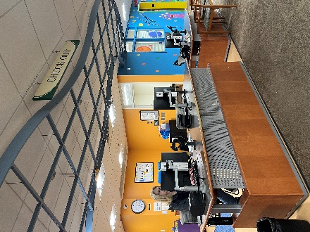If I want to borrow something, I will take it to a library staff member at the check-out desk or I can use the self-service machine to check out my items. If I don’t know how to use it, I can ask a staff member for help.

self-service machine

Check out Desk

The staff will tell me when to bring my items back to the library. I can ask for a receipt that will also tell me when I need to bring them back.

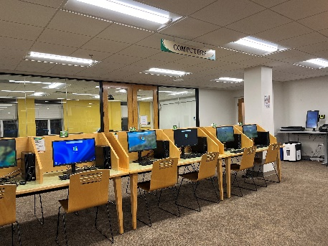The library also has computers and tablets. They are free to use when I am in the library. If I want to use them, I can ask a library staff member to help me.

computers and photocopiers at the library



The library has a photocopying, faxing, and printing service which costs money to use. I can ask a library staff member for help.

# Leaving the Library

When I’m finished, I can leave the library and come back again to visit.